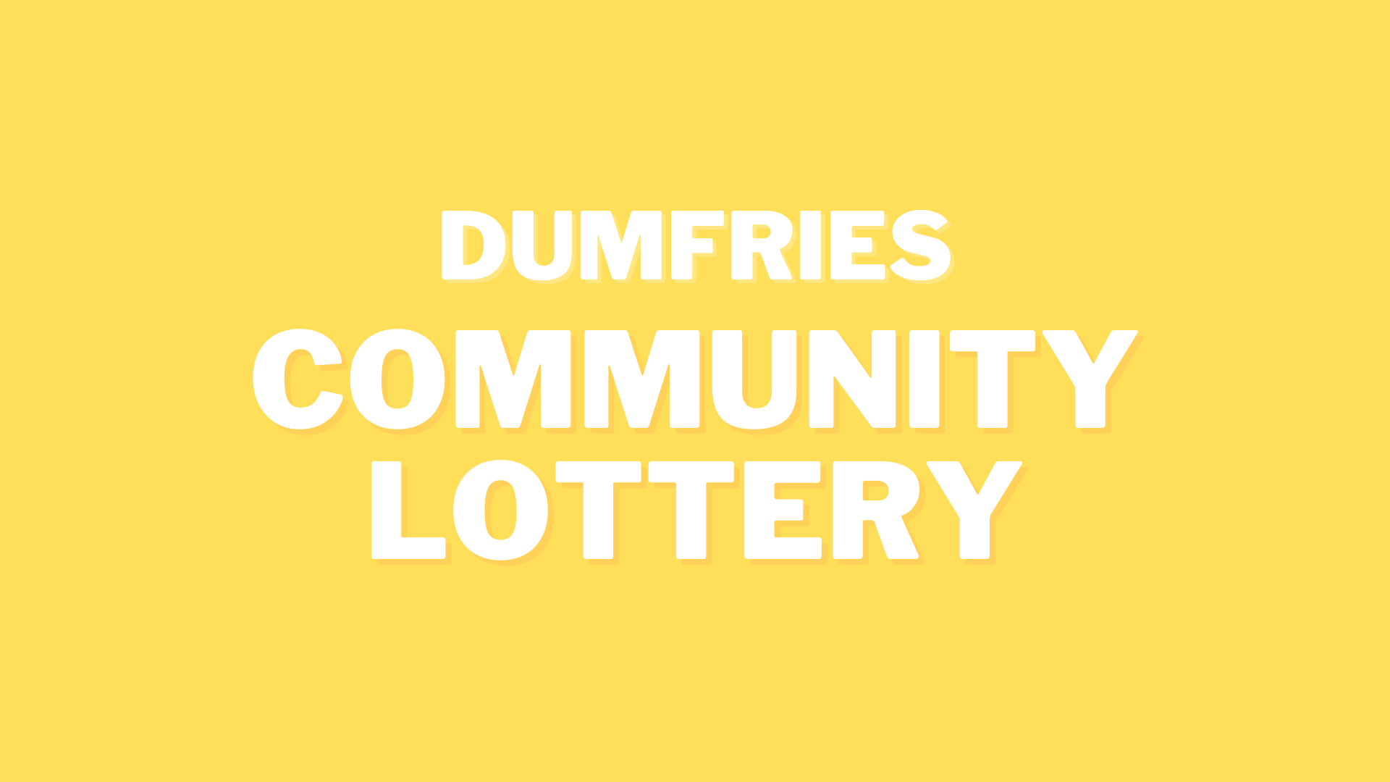

Prizes Terms and Conditions
Updated September 2020

- Cash Prizes
All first place winners will receive a £50 cash prize. To claim your prize, you must complete the Dumfries Community Lottery Monetary Prize Claim form which will be sent to you along with the email notifying you of your win.

The form should be fully completed and sent back to dumfriescommunitylotto@gmail.com along with any other required documents as stated in the notification email. You will receive an email to confirm receipt of the form within 24 hours of sending it.

Payments will be made in 2-3 working days of the form being received by the team.

- IHG Rewards Points
The winner must go to ihg.com and register themselves with IHG Rewards Club. You will be sent an email notifying you of your win, and asked to return your Rewards Club number which will then be passed on by us, and your points claimed. We notify you further when the points have been added.

- A Day of Gardening by Gary Swainson
You will be notified through email of your win, and this email will detail the contact details for Gary, who will arrange a date with you.

If you have any questions or need any help with claiming a prize, please call our team on 01387 733717 or email dumfriescommunitylotto@gmail.com.

