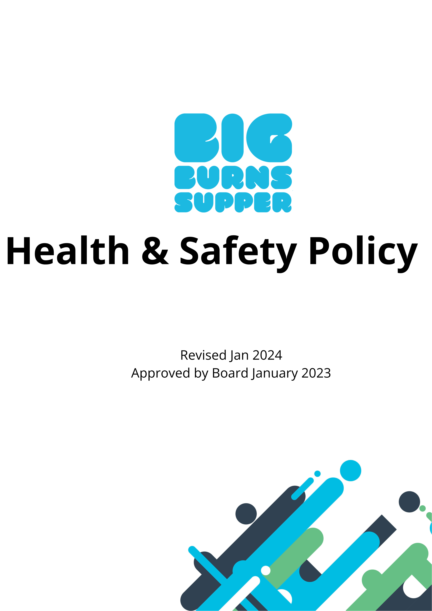

Health and Safety Policy Statement
Electric Theatre Workshop is committed to providing a safe and healthy environment in which participants, volunteers, artists, staff (payroll or freelance), and audiences can enjoy their experience with the organisation. While it is impossible to plan for unavoidable injuries, every reasonably practicable action must be taken to minimise exposure to potential hazard or injury
This document will set out the organisations commitment to ensure all participants, personnel and audiences, enjoy a safe environment across all operational sites. This policy has been approved by the board of trustees and will be reviewed annually
All personnel, full time, seasonal, freelance, or volunteer, should make themselves familiar with this policy, and their duty to uphold the arrangements described herein. It is the legal duty of both management and staff to prevent all types of accidents, and to cooperate and assist in providing and maintaining a safe working environment. Mangers, staff and volunteers should adopt a “See it, Sort it” approach to safety in the workplace. Training will be provided by the organisation for new personnel.
.
LEGISLATION, GUIDANCE & PRINCIPLES
This policy is written in accordance with guidance from the Independent Theatre Council, The Health and Safety Executive and UK Government Legislation; The Health and Safety at Work Act 1974, Management of Health and Safety at Work Regulations 1999, Workplace (Health, Safety and Welfare) Regulations 1992, Health and Safety (Display Screen Equipment) Regulations 1992, Personal Protective Equipment at Work Regulations 1992, Provision and Use of Work Equipment Regulations 1998, Manual Handling Operations Regulations 1992, Health and Safety (First Aid) Regulations 1981, The Health and Safety Information for Employees Regulations 1989, Employers’ Liability (Compulsory Insurance) Act 1969, Reporting of Injuries, Diseases and Dangerous Occurrences Regulations 1995 (RIDDOR). Noise at Work Regulations 1989, Electricity at Work Regulations 1989, Control of Substances Hazardous to Health Regulations 2002 (COSHH).
This policy is based on a principal of risk assessment, risk avoidance, and Mitigation.
RESPONSIBILITIES AND LEGAL DUTIES
It is the responsibility of Managers and Project leaders to;
• Provide and maintain a safe and healthy workplace as required by legislation, across all workspaces used in both permanent and sessional basis.
• Conduct risk assessments for all activity undertaken by personnel and members of the public during the planning phase of project delivery.
• Establish good lasting examples of safe operating procedures.
• Provide all necessary safety equipment and protective clothing
• Monitor safety performance and record all accidents and near misses.
^{Health & Safety Policy}1
The responsibilities of staff and volunteers will be to;
• Works safely at all times and adhere to safe operating procedures and where possible, manufacturers guidelines.
• Cooperate with the company to uphold statutory requirements
• Report all accidents (those involving injury to people, damage to property and near misses) to management as soon as possible so that an investigation may be carried out and preventative action taken.
• Observe all safety rules at all times.
• Must act with due care for the health and safety of themselves, colleagues, and members of the public.
• Must not recklessly misuse or interfere with any equipment that has been provided for safety whilst at work.
• All volunteers and staff must know where all the fire exits, fire extinguishers, fire alarms and assembly points are located in case of emergency.
ARRANGEMENTS FOR SAEFTY AND WELFARE
Electric Theatre Workshop Acknowledges that some accidents are unavoidable. Where is reasonably practicable, Every step should be taken to minimize risk to participants, audience and personnel. Avoiding injury in the workplace means considering a wide range of areas, across all phases of project delivery. These include and are not exclusive to:
Planning
• Assess risks and decide what precautions are needed. This process should be completed by the project leader managing each event and signed off by a Senior Manager, or person deemed competent by a senior manager.
• Prevent or adequately control long and short term exposure to hazards. • Prepare plans and procedures to deal with accidents, incidents and emergencies. This is an event safety management plan should be written for all events produced by Electric Theatre Workshop.
Putting into practice
• Ensure employees are properly informed, trained and supervised. Ensure work equipment, and systems of work are safe.
• Ensure dangerous articles and substances are moved, stored and used safely. • Provide workers with information, instruction, training and supervision; adequate first-aid facilities; protective clothing or equipment.
• Make sure that the workplace satisfies health, safety and welfare requirements, eg for ventilation, temperature, lighting, and sanitary, washing and rest facilities. • Take precautions against danger from flammable or explosive hazards, electrical equipment, noise and radiation.
• Avoid or minimise hazardous manual handling operations.
^{Health & Safety Policy}2
The main hazards – and how to avoid them
Slipping and tripping
According to the Health & Safety Executive (HSE) these accidents account for 33% of all reported major injuries and 2 fatalities per year. Simple actions should be taken to avoid slips and trips in these areas:
• uneven floor surfaces.
• unsuitable floor coverings.
• wet floors.
• changes in levels.
• trailing cables.
• poor lighting.
• poor housekeeping.
Where changes can be made, personnel should adopt a see it sort approach. Where changes cannot be made, the hazard should be highlighted either through signage or hazard tape.
Relevant legislation:
The Workplace (Health, Safety and Welfare) Regulations 1992
Recommended reading:
Preventing Trips & Slips at Works www.hse.gov.uk/pubns/indg225.pdf
Work at heights
Electric Theatre Workshop Acknowledges that the likelihood of working at height during production & manufacturing, load in/outs, and or during performances.
Obvious examples include using temporary access equipment such as scaffolding, tower scaffolds, ladders, step ladders, trestles and tallescopes. Raised scenery and raked stages will carry risks for those working on them, but so will a standard flat stage. Risks of working at height should always be assessed and appropriate measures taken to ensure safety. Workers should be trained in the use of any equipment required for working at height. Identified risks include:
• Falls – work is 'at height' if someone could be injured by falling even at ground level. • Falls from collapsing structures.
• Injury from falling objects.
The following are all requirements in law that you need to consider when planning and undertaking work at height. You must:
^{Health & Safety Policy}3
• Take account of weather conditions that could compromise worker safety; • check that the place where work at height is to be undertaken is safe. Each place where people will work at height needs to be checked every time, before use;
• stop materials or objects from falling or, if it is not reasonably practicable to prevent objects falling, take suitable and sufficient measures to make sure no one can be injured, eg use exclusion zones to keep people away or mesh on scaffold to stop materials such as bricks falling off;
• store materials and objects safely so they won’t cause injury if they are disturbed or collapse;
• plan for emergencies and rescue, eg agree a set procedure for evacuation. Think about foreseeable situations and make sure employees know the emergency procedures. Don’t just rely entirely on the emergency services for rescue in your plan.
Relevant legislation:
The Work at Height Regulations 2005
Recommended reading:
Safe use of ladders and stepladders www.hse.gov.uk/pubns/indg402.pdf
Falls from height – a range of leaflet www.hse.gov.uk/pubns/fallindx.htm
Equity’s Code of Conduct for the Use of Rakes in Theatrical Performances
Hearing
There is already a duty to assess risk from noise and to ensure that action to prevent damage to workers is taken where necessary. This will be made tighter by new regulations. Where there is prolonged exposure to loud noise Electric Theatre Workshop must make protective equipment available to personnel.
Relevant legislation:
Control of noise at Work Regulations 2005 (implemented in April 2006 except music & entertainment April 2008)
Recommended reading:
Advice to employers on www.hse.gov.uk/noise/advice.htm
Hazardous substances
Electric Theatre Workshop acknowledges the risk posed to personnel through exposure to hazardous substances. This risk is present in the day to day activities such as disinfecting and cleaning surfaces, in the production stages of projects through the use of solvents and paints and finishes and in extraordinary activities such as using fog and other special effects in live productions.
Carnival artists, Scene makers, painters and those producing costumes are obviously at risk from hazardous substances. Performers, participants and volunteers, however, may also be at
^{Health & Safety Policy}4
risk from adhesives, paints, cleaning agents, fumes and naturally occurring substances in the costumes they wear and the sets they work on. Commonly used dangerous substances are listed in the HSE publication Approved Supply List. Information approved for the classification and labelling of substances and preparations dangerous for supply. Substances with workplace exposure limits are listed in the HSE publication EH40/2005 Workplace exposure limits.
To minimize harms the organisation will make available gloves, goggles, and protective equipment where is reasonably practicable. All personnel should make use of protective equipment, employ vigilance regarding the equipment and containers related to the use of harmful substances, and should work in well ventilated areas. Any concerns relating to the equipment used or containment of hazardous substances should be reported to a senior manager.
Relevant legislation
Control of Substances Hazardous to Health Regulations 2002 (COSHH)
Recommended website
www.coshh-essentials.org.uk
Manual handling
According to the HSE more than one third of all 'over three day' injuries are caused by manual handling. Electric Theatre Workshop acknowledges that this is not just a problem for the crew. Performers will also face the hazards of get-ins, get-outs and push and pull. Volunteers and other participants are also at risk. All personnel should prior to handling loads large or small should make an assessment as to the safest way to carry out the task.
Assessment of manual handling risks should consider:
• What the task involves. e.g.: how loads are held, does this involve twisting, stooping or large vertical movements; are there long carrying distances, strenuous pushing or pulling or repetitive handling? Then consider whether lifting aids could be used, workplace layout could be changed or carrying distances could be reduced.
• What is the nature of the loads e.g.: are they heavy, bulky, unwieldy, unstable or likely to move? How can these problems be alleviated.
• The capacity of individuals consider if the job requires above-average strength or agility, might endanger those with a health problem or learning/physical disability or pregnant women, might need special information or training?
Relevant legislation
The Manual Handling Operations Regulations 1992, amended 2002
Recommended reading
Getting to grips with manual handling: a short guide www.hse.gov.uk/pubns/indg143.pdf A range of leaflets on Manual Handling can be found at www.hse.gov.uk/pubns/manlinde.htm
^{Health & Safety Policy}5
Sight
Legislation in this area is concerned with those operating display screen equipment e.g. computers and aims to minimise the risk of occupational ill-health, by ensuring that operators or users have:
• Adequate training and information.
• Proper breaks or changes of activity.
• Work stations suitable for them which meet, where necessary, the standards in the schedule.
• Eye tests if they request them.
Relevant legislation
The Health and Safety (Display Screen Equipment) Regulations 1992
Recommended reading
Working with VDUs www.hse.gov.uk/pubns/indg36.pdf
Reporting after an Accident or Injury
Some work-related accidents, diseases and dangerous occurrences must be reported to the HSE, these are:
• Death
• Major injuries e.g
a) Fracture other than to fingers, thumbs or toes.
b) Amputation.
c) Dislocation of the shoulder, hip, knee or spine,
d) Loss of sight (temporary or permanent).
e) Chemical or hot metal burn to the eye or any penetrating injury to the eye. f) Electric shock/burn or any other injury leading to hypothermia, heat-induced illness or unconsciousness, requiring resuscitation or a hospital stay of more than 24 hours. g) Unconsciousness due to asphyxia or exposure to a harmful substance/biological agent. h) Acute illness/loss of consciousness due to absorption of any substance. • Over three day injuries, i.e: where an employee or self-employed person is away from work or unable to work normally for more than three consecutive days.
• An employee suffering from a reportable work-related disease, these include: certain poisonings; some skin diseases such as occupational dermatitis; lung diseases including occupational asthma, pneumoconiosis, asbestosis; infections such as leptospirosis, hepatitis, tuberculosis, anthrax, legionellosis, tetanus; other conditions such as: occupational cancer and hand-arm vibration syndrome.
• Dangerous occurrence; something which does not result in a reportable injury, but which clearly could have done, must be reported immediately, these include: collapse, overturning or failure of load-bearing parts of lifts and lifting equipment; explosion, collapse or bursting of any closed vessel or associated pipework; electrical short circuit or overload causing fire or
^{Health & Safety Policy}6
explosion; accidental release of a biological agent likely to cause severe human illness; collapse of: any building or structure under construction, alteration or demolition, where over five tonnes of material falls; explosion or fire causing suspension of normal work for over 24 hours.
Relevant legislation
Reporting of Injuries, Diseases and Dangerous Occurrences Regs 1995
RIDDOR reporting
Phone the Incident Contact Centre on 0845 300 9923 (local rate) or use the forms provided at www.hse.gov.uk/forms/incident/index.htm
Recommended reading
RIDDOR Explained at www.hse.gov.uk/pubns/hse31.pdf
Compensation after an Accident or Injury
There is not an automatic right to compensation for injury or disease arising out of employment, however, the company is required by the law to insure against liability for injury or disease to employees arising out of their employment in case claims are made. Employers’ liability insurance is compulsory once you have any employees; you can be fined if you do not hold a current policy. The company must be insured for at least £5 million; in practice, most insurers offer minimum cover of £10 million. The company must display a copy of the Certificate of Insurance where your employees can easily read it. Expired insurance certificates must be retained for at least 40 years because claims for diseases can be made many years after a disease is caused.
Injuries or illness relating to motor accidents which may occur while personnel are undertaking ETW activity should be covered by their own fully comprehensive cover. Electric Theatre Workshop does not accept responsibility for damage to personal vehicles, other vehicles must be insured as part of their hire agreement.
Public liability insurance may need to be purchased in circumstances where a venue does not have insurance (particularly pop up performances and unconventional venues.) it is the responsibility of senior managers to ensure that insurance policy purchased is suitable for the events/ activity organized and venue.
Relevant legislation
Employers Liability (Compulsory Insurance) Act 1969
Recommended Reading
Employers Liability (Compulsory Insurance) Act 1969: A Guide for Employers www.hse.gov.uk/pubns/hse40.pdf
^{Health & Safety Policy}7

